Project Design Phase-II
Data Flow Diagram & User Stories

Date | 31 January 2025
Team ID | LTVIP2026TMIDS88461
Project Name | DocSpot — Seamless Appointment Booking for Health
Maximum Marks | 4 Marks

Data Flow Diagrams:
A Data Flow Diagram (DFD) is a traditional visual representation of the information flows within a system. A neat and clear DFD can depict the right amount of the system requirement graphically. It shows how data enters and leaves the system, what changes the information, and where data is stored.
Example: DFD Level 0 (Industry Standard)

Example: (Simplified)
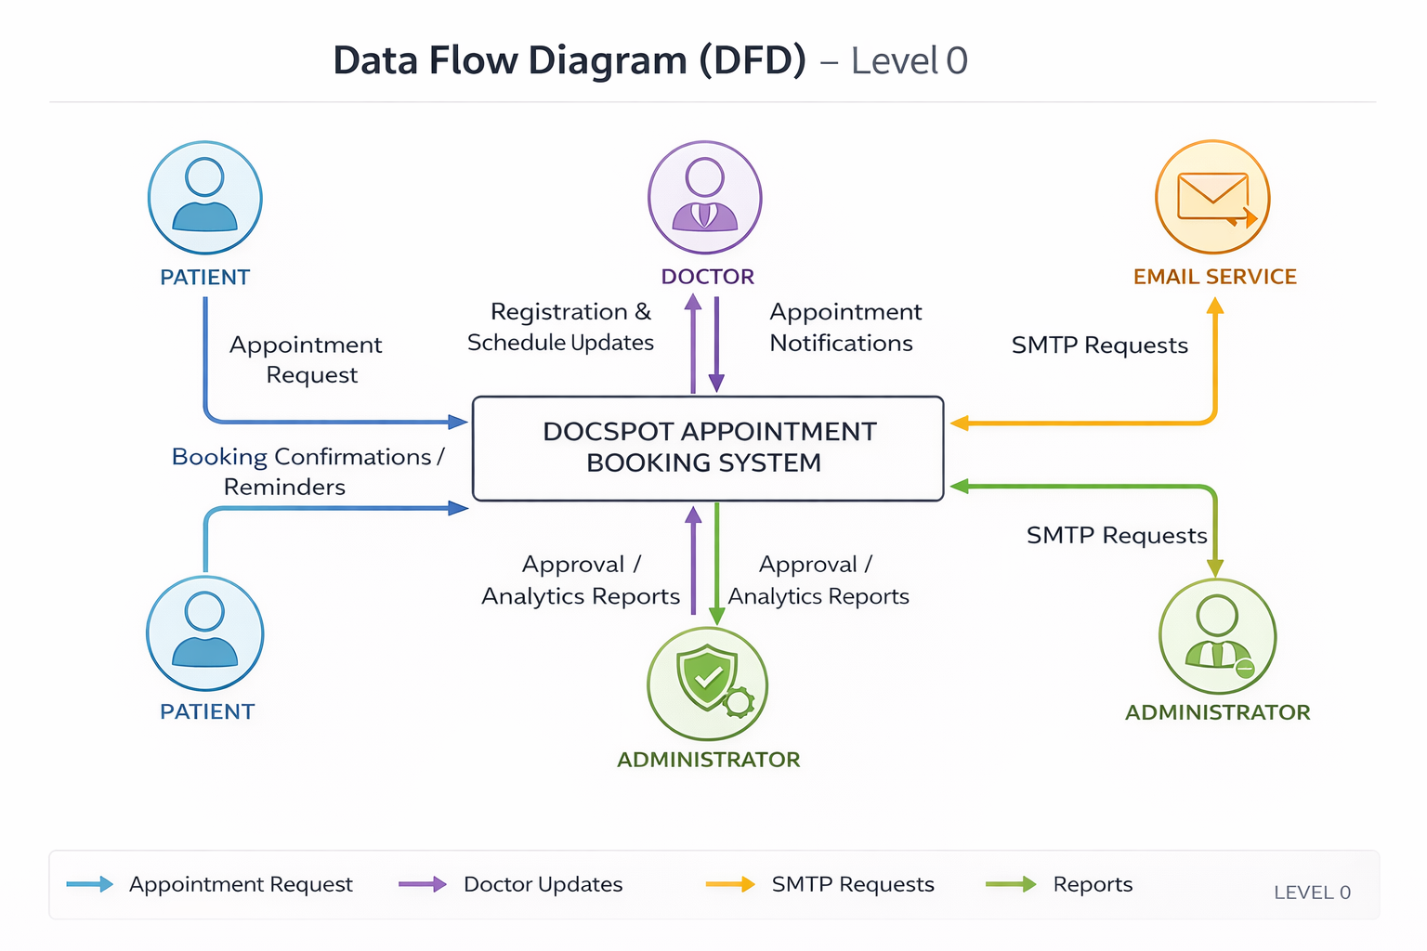
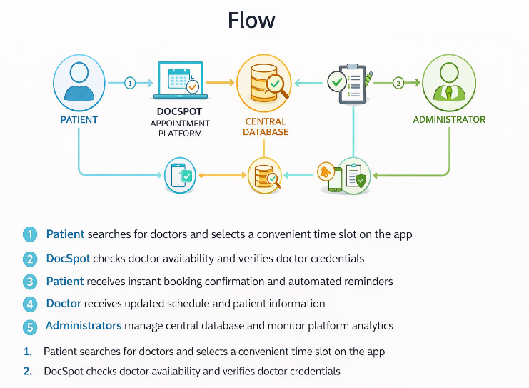

User Stories

User Type | Functional Requirement (Epic) | User Story Number | User Story / Task | Acceptance Criteria | Priority | Release
Customer (Mobile) | Registration | USN-1 | As a user, I can register using email and password. | User account is created and dashboard is accessible. | High | Sprint-1
Customer (Mobile) | Login | USN-2 | As a user, I can log in using valid credentials. | User is redirected to dashboard after authentication. | High | Sprint-1
Customer (Mobile) | Password Reset | USN-3 | As a user, I can reset my password via email. | Password reset link is sent and new password is saved successfully. | High | Sprint-1
Customer (Mobile) | Profile Management | USN-4 | As a user, I can view and update my profile details. | Updated information is saved in database and reflected in UI. | High | Sprint-1
Customer (Mobile) | Doctor Search | USN-5 | As a user, I can search doctors by specialization or location. | Relevant doctors are displayed based on search filters. | High | Sprint-1
Customer (Mobile) | Doctor Profile | USN-6 | As a user, I can view doctor details including qualification and fees. | Doctor profile displays correct and complete information. | High | Sprint-1
Customer (Mobile) | Appointment Booking | USN-7 | As a user, I can book an appointment with an available time slot. | Appointment is created and confirmation message is shown. | High | Sprint-1
Customer (Mobile) | Appointment Management | USN-8 | As a user, I can reschedule or cancel my appointment. | Appointment status updates correctly and email notification is sent. | High | Sprint-1
Customer (Mobile) | Notifications | USN-9 | As a user, I receive email notifications for booking and status updates. | Email is triggered successfully via queue system. | Medium | Sprint-1
Customer (Web) | Advanced Search | USN-10 | As a web user, I can apply advanced filters like ratings and availability. | Filtered results display accurately. | Medium | Sprint-2
Doctor | Registration | USN-11 | As a doctor, I can apply for registration with credentials upload. | Application status is set to pending approval. | High | Sprint-1
Doctor | Availability Management | USN-12 | As a doctor, I can configure working hours and available slots. | Available slots are visible to patients in booking system. | High | Sprint-1
Doctor | Appointment View | USN-13 | As a doctor, I can view my scheduled appointments. | Doctor dashboard shows appointments sorted by date. | High | Sprint-1
Doctor | Status Update | USN-14 | As a doctor, I can update appointment status (Completed/Cancelled). | Status changes reflect in database and notify patient. | High | Sprint-1
Admin | Doctor Approval | USN-15 | As an admin, I can approve or reject doctor applications. | Doctor status updates and email notification is sent. | High | Sprint-1
Admin | User Management | USN-16 | As an admin, I can suspend or activate user accounts. | User access is updated immediately in system. | High | Sprint-1
Admin | Appointment Monitoring | USN-17 | As an admin, I can view all appointments across the platform. | Admin dashboard displays appointment list with filters. | High | Sprint-1
Admin | Analytics Dashboard | USN-18 | As an admin, I can view total users, doctors, and appointment metrics. | Dashboard displays real-time statistics with charts. | Medium | Sprint-2
Admin | Audit Logs | USN-19 | As an admin, I can view system audit logs for security tracking. | Logs are searchable and securely stored. | Medium | Sprint-2

